Trapped in Poverty
Accessibility, Availability, and Income in Erie County, Pennsylvania

Table of Contents

Table of Contents 1
About the Jefferson Civic Leadership Academy 2
Introduction 3
Methods 8
Erie County, Pennsylvania 13
Population 13
Age and Fertility 16
Race 18
Household Characteristics 20
Housing Occupancy, Home Values, and Transportation 22
Education, Employment, Occupation, and Industry 23
Poverty in Erie County 26
Income and Poverty 26
Statistical Breakdown 30
ZIP Code by Median Household Income 31
The Community Poverty Index 35
Conclusion 37
Recommendations 39
Works Cited 40
Works Consulted 41

About the Jefferson Civic Leadership Academy
Launched in 2015, the Jefferson Civic Leadership Academy prepares Erie professionals, approximately ages 25-45, for meaningful, fulfilling, and impactful engagement in their community by providing a dynamic and unique environment that fosters teamwork, growth, and learning through a transformative experience for those seeking to be change-agents for their community. Through the Leadership Academy, students examine the inner workings of local governments to emerge as civic leaders capable of effecting positive change for Erie County's future with an understanding of Erie's past and present. With a close look at Erie's economic, entrepreneurial, and innovation ecosystems, the Leadership Academy informs mindful leaders of Erie's post-industrial landscape while exposing them to global ideas that can be applied to Erie County's overall developmental health and well-being.

Introduction
Erie County is in crisis. Poverty rates exceed both the state and national averages in a number of economic indicators, including unemployment, the number of people on public assistance; and it lags in important community development indicators such as public health and educational attainment. In the City of Erie, some of these indicators register at approximately twice the national average.
A number of local initiatives attempt to thwart the spread of poverty in Erie County. The United Way of Erie County made its mission to “crush poverty.” Erie’s Public Schools implemented and continues to develop its community schools program throughout the district. Erie County government will initiate its first “Blue Zone” – a strategy to increase the collective public health of communities – in 2019 in Corry, Pa. and numerous social service and faith-based organizations continue to target inner-city neighborhoods and rural areas.
In Erie County, efforts have been comprehensive. Yet, poverty persists.
 |  | Related children under 18 years
Size of family unit | Weighted | None | One | Two | Three | Four | Five | Six | Seven | Eight or more
 | average
 | thresholds
One person (unrelated individual): | 12,488
Under age 65 | 12,752 | 12,752
Aged 65 and older | 11,756 | 11,756
Two people: | 15,877
Householder under age 65 | 16,493 | 16,414 | 16,895
Householder aged 65 and older | 14,828 | 14,816 | 16,831
Three people | 19,515 | 19,173 | 19,730 | 19,749
Four people | 25,094 | 25,283 | 25,696 | 24,858 | 24,944
Five people | 29,714 | 30,490 | 30,933 | 29,986 | 29,253 | 28,805
Six people | 33,618 | 35,069 | 35,208 | 34,482 | 33,787 | 32,753 | 32,140
Seven people | 38,173 | 40,351 | 40,603 | 39,734 | 39,129 | 38,001 | 36,685 | 35,242
Eight people | 42,684 | 45,129 | 45,528 | 44,708 | 43,990 | 42,971 | 41,678 | 40,332 | 39,990
Nine people or more | 50,681 | 54,287 | 54,550 | 53,825 | 53,216 | 52,216 | 50,840 | 49,595 | 49,287 | 47,389
Source: U.S. Census Bureau.
The overall poverty rate in Erie County (17%) exceeded both the state (13%) and national (15%) poverty rates in 2017, the most recent statistical year available. That is a 5 percent increase since 2000, when the poverty rate in Erie County equaled the national poverty rate (12%) and was one percentage point higher than the poverty rate in Pennsylvania (11%).0F The rate at which poverty continues to grow in Erie County is significant, leaving many to ask why poverty persists at high rates in Erie County despite past and current initiatives.
Poverty, according to the U.S. Census Bureau, is defined as a family of four (two adults and two children) with a median household income of $24,858 or less. More difficult to categorize are those families and individuals – among the 61 percent of Americans who would not be able to sustain a $1,000 emergency – whose incomes approach the poverty line and may be within one car problem, one medical issue, or one missed paycheck away from more serious economic and personal hardships.1F These individuals often receive some form of social assistance, such as childcare, SNAP, or public housing.
Those who receive some benefits, may also have less job mobility in order to keep a benefit. According to the nonprofit anti-poverty organization Circles USA, “an increase of less than $50 a month can lead to the loss of several hundred dollars’ worth of programs,” leaving families without the necessary means to meet the basic nutritional, medical, and other needs of the household.2F The “cliff-effect,” as it is known, is among the systemic impediments to economic independence in the United States, particularly in regions such as Erie, where skilled labor is being replaced by lower-wage jobs in the health care, social assistance, leisure, and hospitality, among others, and nominal local economic growth (1.8%) compared to the state (24%) and the nation (30%).3F Said one working mother from Erie:
I was on welfare for over 10 years. It’s a very nice program for low-income families, but when I started working all of my food stamps and health insurance were taken away from me. I was able to provide food for my family but unable to provide health insurance. My family was without health insurance for two years until I started working as a registered nurse full time. I still have bills to pay off from when they had doctors’ appointments and medical bills.
Children Living in Poverty (Under Age 18)
 | 2000 | 2008-12 | 2013-17
United States | 17% | 21% | 20%
Pennsylvania | 15% | 18% | 19%
Erie County, PA | 16% | 24% | 25%
Broome County, NY | 16% | 24% | 23%
Stark County, OH | 13% | 22% | 22%
Luzerne County, PA | 15% | 25% | 26%
Erie City | 27% | 40% | 39%
Source: U.S. Census Bureau
Notes: Multiyear results are from rolling American Community Survey. * Margin of error between 20% & 35% of estimate; ** margin of error between 35% & 50%; *** margin of error greater than 50%.
Financial uncertainty such as this serves as the bedrock of generational poverty in places like Erie, and it manifests in the number of children living in poverty in Erie County. According to 2017 Census Bureau estimates, the number of children under the age of 5 living in poverty in Erie County is 32.3 percent. In the City of Erie those estimates are above 45 percent for the same age bracket. As a benchmark for the future of the region, Erie’s situation is dire. Compared to counties of similar size that are historically centers of manufacturing and have experienced significant economic challenges as a result of changes in industry and population, the number of children living in poverty continues to grow at rates greater than the population as a whole.
The United Way of Erie County has identified three primary factors that impact generational poverty throughout the region: 1) family-sustaining jobs, 2) single-parent households, and 3) education. The average annual wage for a person working a full-time job in Erie is $40,860, which is 22 percent less than the state average; more than 39 percent of households are single-parent households in Erie County; and 14 percent of people with a high school diploma or equivalent live in poverty. Without a high school diploma or GED that number more than doubles to 31.5 percent.4F
While the ongoing efforts to address poverty in Erie County are numerous and noble, the challenges continue to grow. Potential solutions are complex. For example, advocates for education as a solution to poverty also recognize that educational success is linked to the lifestyle of the student. If the student is unrested, undernourished, and taxed by personal issues that reside largely outside the school, educational success is unlikely.5F If a single parent works multiple jobs to support the family, his/her absence from the home is likely to cause instability for the children s/he works to support.
This project intends to identify and address structural impediments to elevating the economic status of people living in poverty by examining a selection of resources in low-income, middle-income, and high-income ZIP codes across Erie County. Our findings address the following questions:
- Which ZIP codes in Erie County represent a range (low, median, high) of median household income?
- How does accessibility and availability of food items affect the cost of living for families across income groups (low, middle, high income)?
Our research is highly focused on food prices and the cost of living based on the accessibility and availability of nutrient-rich foods as identified by the U.S. Department of Agriculture. According to the Consumer Expenditure Survey, households with a gross annual income of less than $20,000 spend nearly twice as much of their total disposable net income on food in the home (10.2%), than do households that make greater than $150,000 annually (5.4%). Such inequality has a profound impact on the economic stability and the overall quality of life of those living in poverty. Therefore, we identified both chain and non-chain grocers in urban, suburban, and rural communities to determine the availability and cost differences of select items to assess the economic impact of a basket of goods on a family of four in various regions of Erie County. Further, we evaluate the availability of select resources, such as educational institutions, medical care, and public transportation in Erie’s poorest communities.
In the next section, we provide an overview of demographic changes in Erie County during the past two decades to provide context for the scope of the community and the diversity of need that is represented in Erie. What follows is an overview of poverty in Erie County based on measurements drawn from the U.S. Census Bureau’s American Community Survey and other longitudinal census data. The project concludes with the findings of primary data analysis, which unpacks the accessibility, availability, and income disparities that contribute to poverty in Erie County as well as a series of recommendations for policy implementation and future research.

Methods

This study incorporates primary data collected by JCLA participants as well as secondary demographic and economic data curated from local, state, and national sources including Erie County Government, the Pennsylvania Department of Agriculture, as well as the federal Bureau of Labor and Statistics, and the American Community Survey. The primary data allows us to compare food prices in poor, middle-income, and high-income ZIP codes across Erie County in both rural and urban settings. Previous studies conclude that different types of grocery stores across different geographic areas within the same geographic region offer myriad pricing schemes that adversely affect poor people.6F Chung & Myers found that those who shop at non-chain stores pay the highest premium for groceries. Therefore, they argue, “the biggest factor contributing to higher grocery costs in poor neighborhoods is that large chain stores, where prices tend to be lower, are not located in these neighborhoods.”7F
Food prices are one consequential variable in what economists commonly refer to as a “basket of goods.” The basket of goods is used to establish the U.S. Consumer Price Index, the Consumer Expenditure Survey, and the World Bank’s Poverty Inequality Handbook. The Consumer Expenditure Survey, for example, found that households with a gross annual income of less than $20,000 spend nearly twice as much of their total disposable net income on food in the home (10.2%) than do households gross annual incomes of $150,000 (5.4%) or more (Goldstein, 2012). Such inequality has a profound impact on the economic stability and the overall quality of life of those living in poverty.
Select Zip Codes |  | Location | Median Household Income
Poor Urban | 16501 | Erie City | $10,631
 | 16503 | Erie City | $22,918
 | 16507 | Erie City | $28,347
Poor Suburban | 16509 | Millcreek / Kearsarge (Upper Peach) | $44,643
 | 16443 | West Springfield | $45,074
 | 16407 | Corry / Columbus / Elgin / Concord / Lovell / Wheellock | $45,708
Mid | 16411 | Springfield Twp. | $46,496
 | 16423 | Lake City | $47,568
 | 16438 | Union City | $48,521
Wealthy | 16421 | Harborcreek | $60,833
 | 16410 | West of Edinboro / Not Albion | $62,917
 | 16442 | Wattsburg | $63,182
in poverty.
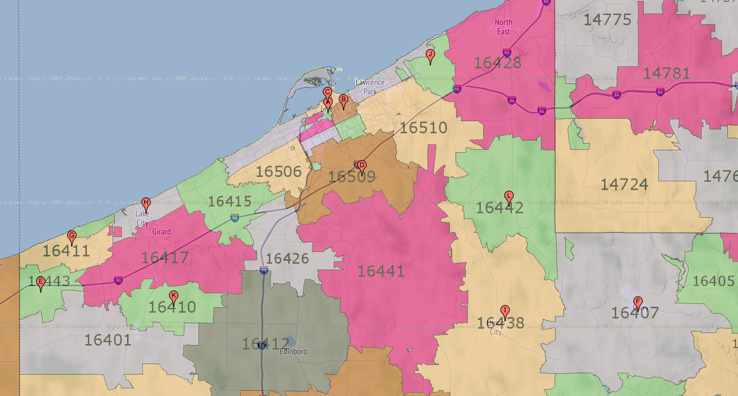
Secondary data shapes a macro-level demographic snapshot of Erie County in 2018 as well as a comparative picture of Erie County over time and in juxtaposition to poverty in the Commonwealth of Pennsylvania and across the United States. Qualitative interviews were conducted with those who formerly or currently live at or near the fiscal cliff. And economic census data was used to identify the median household income in each ZIP code in Erie County, Pennsylvania. Initially, the study was to include the three poorest ZIP codes, three median income ZIP codes, and the three highest median household income neighborhoods. However, the three poorest ZIP codes were all located within the City of Erie. Therefore, in order to assess and compare poverty in both the urban and suburban/rural, the first three poorest ZIP codes outside of the City of Erie were added to the research design. These 12 ZIP code areas became the units of analysis for housing prices, access to education, medical care, and transportation, among other variables. Primarily, these ZIP codes were used to identify the number and type of food stores across Erie County.
Selected Erie County Zip Codes

Food items were selected to be surveyed at each food store in each of the selected ZIP codes. The 49 items were chosen based on the U.S. Department of Agriculture weekly Thrifty Food Plan for a family of four. This food plan specifies the quantity and type of food necessary to meet daily nutritional needs, as well as a selection of common grocery items. The various food and grocery items were divided into six groups for comparison of shelf prices and product availability (Chung & Meyers, 1999).

Data collection worksheets identifying the food and personal items were distributed to all members of the group action project who self-selected from among the identified ZIP codes where they collected data related to product price and availability. All participants were instructed to collect data between November 5 and November 11 in an effort to avoid the first and the fifteenth of the month when some research has indicated that prices fluctuate as a result of the distribution of public food assistance (Chung & Meyers, 1999).
Surveyed Food Items
No. | Group A | Group B | Group C | Group D | Group E | Group F
1 | Apples | Bacon | Orange Juice | Tuna | Corn Flakes | Baby Formula
2 | Bananas | Chicken | Oatmeal | Peas | Raisin Bran | Toothpaste
3 | Nectarines | Ground Beef | Ketchup | Creamed Corn | Vegetable Oil | Tampons
4 | Tomatoes | Rib Chop | Mayonnaise | Canned Corn | White Bread | Carbonated Soft Drinks
5 | Celery | Milk | Raisins | Canned Tomatoes | Wheat Bread
6 | Lettuce | Eggs | Syrup | White Rice | Hamburger Buns
7 | Cabbage | Margarine | Peanut Butter | Potatoes | Spaghetti
8 | Green Peppers | Butter | Sugar | Navy Beans
9 | Carrots | Cheese | Corn Meal | Kidney Beans
10 | Onions |  | Flour
Subsequently, the grocery data was combined with other economic variables to create the Community Poverty Index (CPI), which allows the community to place a weight on the costs of poverty across ZIP codes in Erie County. The CPI was calculated by taking the mean basket price of available goods in the selected ZIP code and multiplying it with the sum of the maximum number of available goods divided by the minimum number of available goods plus the fair

market rate for a three-bedroom apartment in Erie County divided by the median household income for the ZIP code multiplied by 100.

CPI = Average Available Basket Price x (max available goods/min available goods) + FMR Housing / Median HH Income x 100

The result provides an index range that allows us to compare the cost of poverty within each ZIP code while controlling for both access and availability to central household items. This tool allowed the group action team to comparatively assess poverty in Erie County as well as established a tool for future evaluation and longitudinal assessment.

Erie County, Pennsylvania

Population
Since the middle of the 20th century, Erie County’s population growth has slightly exceeded that of Pennsylvania’s but has fallen far short of the overall national trend: the post-war manufacturing boom allowed Erie County to exhibit a 27.89 percent population growth rate – compared to Pennsylvania’s 21 percent growth – from 1950 to 2010, while the United States’ population more than doubled. However, as the financial markets crippled and technological change prompted a sweeping economic overhaul in the late 2000s and early 2010s, Erie County’s population declined alongside of its manufacturing sector, with an overall drop in population from 2000 to 2017. In comparison, both Pennsylvania and the nation experienced an increase in population during this same period.9F
A more rigorous analysis of Erie County shows that a select few townships – each being suburban and rural or semi-rural – captured the majority of the population gains from 2000 to 2016, leaving urban and deeply rural areas to bear the brunt of the county’s population decline.10F Conneaut Township, Greenfield Township, Summit Township, and Wattsburg Borough captured double-digit population growth rates. In terms of numerical growth, however, suburban Millcreek, Summit, and Harborcreek townships boast the county’s highest respective gains of 1,819, 1,381, and 1,254 people, while other notable gains during this time were made by McKean Borough. Fairview Township merged with Fairview Borough in 1998, resulting in a roughly 30 percent population increase from 1990 to 2000, yet from 2000 to 2017, the semi-rural township grew minutely.11F

Meanwhile, Erie County’s urban and smaller, deeply rural areas shed the largest population from 2000 to 2017. In terms of population percentage, the county’s small, deeply rural portions exhibited the highest rates of loss, such as Elgin Borough, Platea Borough, Amity Township, and Concord Township. The City of Erie dominates the County with a total loss of 4,747 people during this period. The City of Corry – the other Erie County city, with Erie City being the larger and more metropolitan of the two – saw a significant decline in population, as well.12F
According to World Population Review’s analysis, Population of Counties in Pennsylvania (2018), Erie County overall has shrunken only slightly and currently is Pennsylvania’s 15th most populous county (of 67 counties). The declining rate of growth threatens the county’s standing, however, as it exists statistically between the growing Cumberland and Dauphin counties, each with estimated 2018 populations of 250,066 and 275,710 people and seven-year growth rates of 6.01 percent and 2.79 percent, respectively.13F

 | 2000 | 2000 | 2000 | 2000
Age | Pennsylvania | Erie County | Pennsylvania | Erie County
0-4 years | 727,804 | 17,440 | 5.93% | 6.21%
5-19 years | 2,542,780 | 62,652 | 20.70% | 22.31%
20-34 years | 2,306,572 | 55,644 | 18.78% | 19.81%
35-64 years | 4,784,733 | 104,851 | 38.96% | 37.33%
65+ years | 1,919,165 | 40,256 | 15.63% | 14.33%
TOTAL | 12,281,054 | 280,843 | 100.00% | 100.00%
 | 2010 | 2010 | 2010 | 2010
Age | Pennsylvania | Erie County | Pennsylvania | Erie County
0-4 years | 729,538 | 16,757 | 5.74% | 5.97%
5-19 years | 2,449,852 | 57,384 | 19.29% | 20.45%
20-34 years | 2,385,265 | 55,055 | 18.78% | 19.62%
35-64 years | 5,178,417 | 110,546 | 40.77% | 39.40%
65+ years | 1,959,307 | 40,824 | 15.42% | 14.55%
TOTAL | 12,702,379 | 280,566 | 100.00% | 100.00%
 | 2017 | 2017 | 2017 | 2017
Age | Pennsylvania | Erie County | Pennsylvania | Erie County
0-4 years | 711,647 | 15,764 | 5.56% | 5.67%
5-19 years | 2,334,185 | 53,989 | 18.25% | 19.43%
20-34 years | 2,508,208 | 56,083 | 19.61% | 20.19%
35-64 years | 5,055,443 | 106,783 | 39.52% | 38.44%
65+ years | 2,181,022 | 45,175 | 17.05% | 16.26%
TOTAL | 12,790,505 | 277,794 | 100.00% | 100.00%
Source: U.S. Census data [2000; 2010]; American Community Survey [2017]

Age and Fertility
Though Erie County’s population is, on average, younger than that of Pennsylvania. Erie County’s population is composed of a higher percentage of 0 to 34-year-olds than Pennsylvania’s, a trend dating to 1980. Notably, the population’s share of 0 to 4 year olds, 5 to 9-year-olds, and 10 to 14-year-olds has declined slightly from 2000 to 2017, indicating that as Erie County’s population ages, the overall declining population trend will likely continue.14F
According to the Pennsylvania Department of Health’s birth statistics, Erie County’s general fertility rate stands about equal to that of Pennsylvania, but its birth rate is significantly elevated in younger females, specifically ages 15 to 19-years-old and 20 to 24-years-old. This is significant in regards to poverty because teen parents face obstacles that perpetuate the cycle of poverty, including disruptions in educational and career goals. A study by the National Conference of State Legislatures found that 63 percent of teen parents receive public assistance in the first year of a child’s life and 52 percent of mothers on welfare had their first child when they were teen aged.15F
Erie County Birth Statistics
[2012 to 2016]
Measure | Erie | Interval (95%) | Pennsylvania | Comparison
Percent cesarean section births | 36.9 | (36.0 - 37.9) | 30.6 | Higher
Percent low birth weight births | 7.9 | (7.4 - 8.3) | 8.2 | Similar
Percent prenatal care in 1st trimester births | 79.1 | (77.7 - 80.50) | 72.5 | Higher
Percent preterm births | 8.6 | (8.2 - 9.1) | 9.4 | Lower
Percent non-smoking mother births | 79.8 | (78.4 - 81.2) | 86.7 | Lower
General fertility rate - ages 15 to 44 | 58.6 | (57.7 - 59.5) | 58.5 | Similar
Birth rate - ages 15 to 19 | 23.9 | (22.5 - 25.3) | 19.4 | Higher
Birth rate - ages 20 t0 24 | 76.5 | (74.1 - 78.9) | 67.6 | Higher
Birth rate - ages 25 to 29 | 103.7 | (100.7 - 106.6) | 99.2 | Higher
Birth rate - ages 30 to 34 | 93.3 | (90.3 - 96.2) | 103.6 | Lower
Birth rate - ages 35 to 39 | 40.3 | (38.2 - 42.3) | 49 | Lower
Birth rate - ages 40 to 44 | 7.8 | (7.0 - 8.7) | 9.2 | Lower
Source: Pennsylvania Department of Health: Birth Statistics 2012 - 2016

Race
Though Pennsylvania is overwhelmingly Caucasian, the state has experienced a slight decrease in that demographic and a slight increase in other races. In 2000, Pennsylvania’s population was identified as being 85.40 percent Caucasian but, by 2017, each minority population grew, lowering the statewide Caucasian population to 81.14 percent, as Pennsylvania slowly becomes more diverse.
Like the Commonwealth, Erie County remains predominantly Caucasian but diversity has increased slightly since 2000. From 2000 to 2017, Erie County’s Caucasian population has fallen, while its African-American population share increased 1 percentage point. In addition, the county’s Asian population share roughly doubled from 0.7 percent to 1.6 percent, while the remaining portions of the population also grew to some extent.
Erie County’s Hispanic population continues to grow, as well, with the race’s population share increasing from 2.18 percent in 2000 to 4.01 percent in 2017. Even in the face of such growth, Erie County’s Hispanic population growth falls behind that of the state’s, which boasted a Hispanic population growth rate of more than 120 percent from 2000 to 2017. In comparison, Erie County’s Hispanic population growth rate across the same time span is 82.04 percent.16F
Thus, as Erie County’s population declines, its diversity slightly rises – yet the county remains considerably Caucasian and Pennsylvania diversifies at a faster rate across the board. As one may expect, the distribution of Erie County’s diversity is centralized in its urban and suburban centers – specifically the City of Erie and Millcreek Township. With the exception of the City of Erie, Edinboro Borough, and Conneaut Township, every other township or borough in the County exhibits a Caucasian population share well above 90 percent. The statistically least diverse area in Erie County is Elgin Borough, the county’s smallest municipality, exhibiting a 100.00 percent Caucasian population share, but a 2017 population total of only 178 people.17F

Household Characteristics
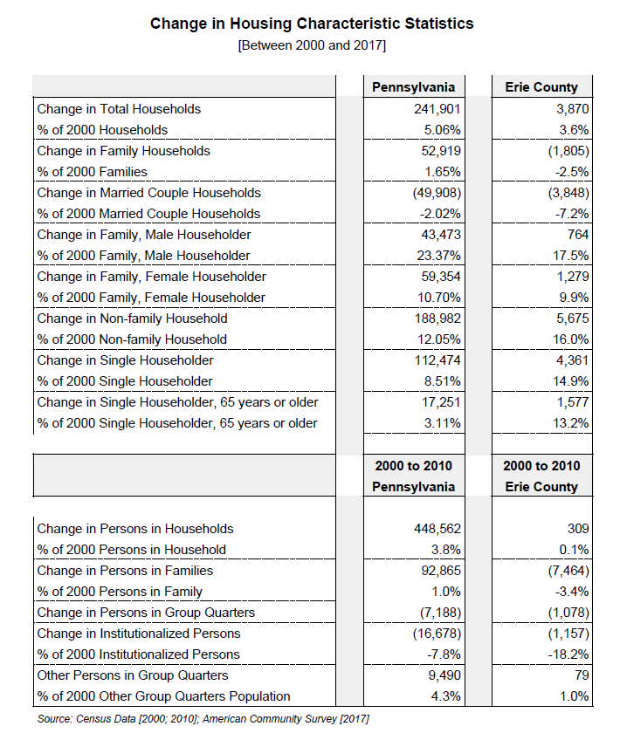
The number of single-parent households grew between 2000 and 2017, with male householders growing at a faster rate than female householders. However, female householders make up the vast majority of single-parent households. Though the number of households climbed slightly in Erie County, the number of family households and married couple households dropped. In 2017, Erie County saw a rise of almost 4 percent from the amount of total households in 2000. However, the county saw a decline in total family households and married couple households. The average family size in Pennsylvania and Erie County continues to hover around three people and a typical household size of about 2.5 people.18F
Complementing the high percentage of single-parent households in metropolitan areas, the lowest percentages of married couple households tend to also reside in the urban areas of Erie County. In 2010, the City of Erie held the lowest rate of married couple households, followed by Corry, while Millcreek Township was above the Erie County average. The highest rates of married couple households in Erie County in 2010 were found in Amity Township and Venango Township – both small, rural areas.19F

Housing Occupancy, Home Values, and Transportation
As of the 2017 United States Census, Erie County contained more than 120,000 housing units, with about two-thirds of occupied units being owner-occupied and the remaining units being renter-occupied. Erie County’s 2017 vacancy rate was higher than that of other Pennsylvania communities but slightly lower than that of the county’s previous decades’ measurements.
Erie County home values rose from 2000 to 2017 as the amount of housing units valued at or above $200,000 quadrupled and the rate of housing units valued below $50,000 dropped from 14.4 percent to 10.9 percent. However, the 2017 median home value in Erie County was $124,100 – more than 37 percent lower than Pennsylvania’s 2017 median home value of $170,500. The direct effect of the financial and housing crisis near the end of that decade on Erie County home values is not shown by the data being analyzed.
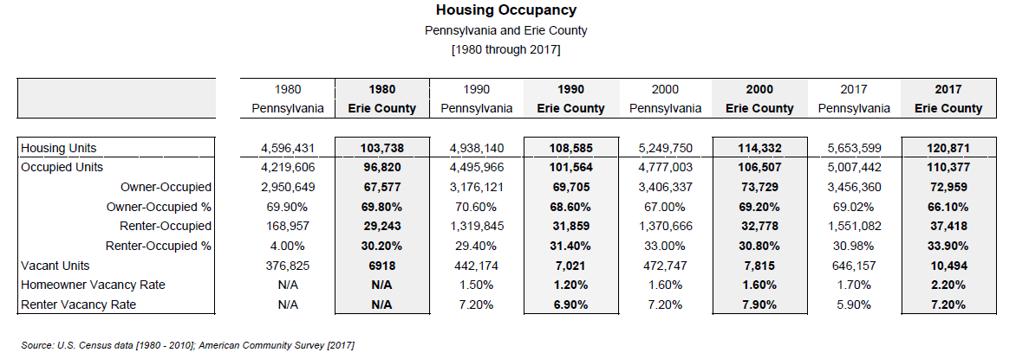
The vast majority of individuals in Erie County drive an automobile. In 2017, 89.7 percent of Erie County residents’ primary means of transportation was an automobile, with 78.8 percent driving alone. Approximately 1.7 percent primarily used public transportation, while 3.9 percent walked.20F

Education, Employment, Occupation, and Industry
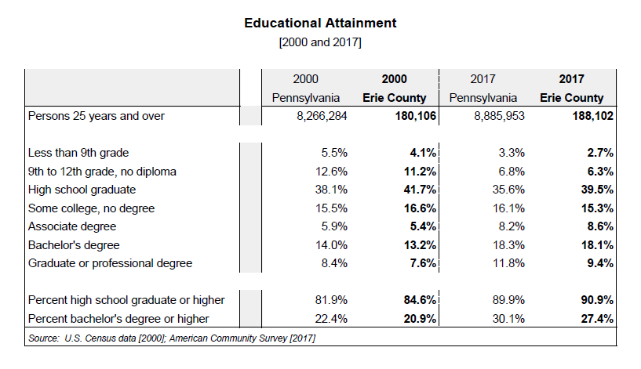
Erie County is seeing a rise in the percent of residents with college degrees, though the figure still sits slightly below that of Pennsylvania. For example, the share of Erie County’s population that held a high school degree or higher in 2017 was just 1 percent higher than the commonwealth, while Pennsylvania exhibits a slightly higher population share with bachelor’s degrees or higher when compared to Erie County. Erie County as a whole, though, is seeing a slight rise in the share of its population that holds some sort of college degree, while graduate and professional degree-holders are also increasing in share.21F
As Erie County’s labor force declines, its unemployment rate rises, indicating that the county’s supply of jobs is dropping at a faster rate than the demand for them. Since 2000, Erie County’s civilian labor force has been reduced from 140,700 people to 130,800 people in 2017 – a 7.04 percent drop. Additionally, the county’s unemployment rate has fluctuated between a new millennium-low of 4.5 percent in 2000 to a new millennium-high of 9.3 percent in 2010. In 2017, the unemployment rate was 5.8 percent, a 1.30 percent net increase since 2000.22F
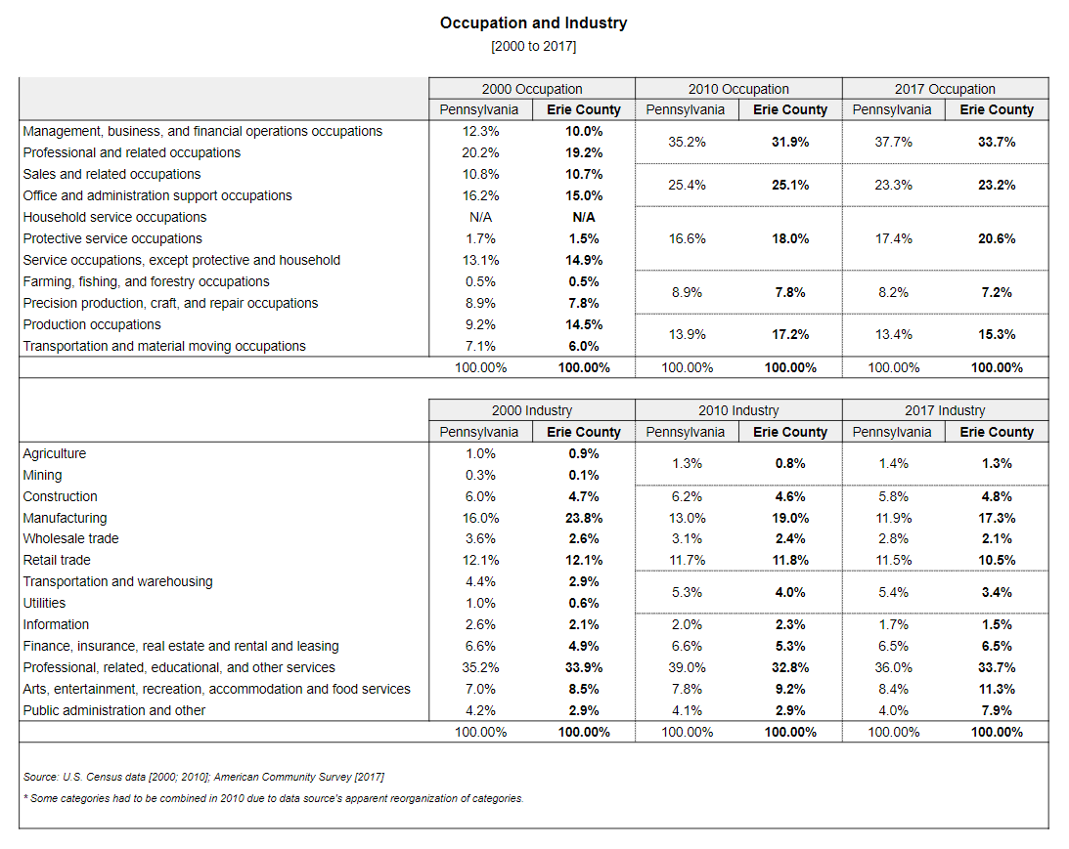
The manufacturing industry – the classic economic lifeblood of Erie County – has sharply declined by nearly half in the region in recent decades. Where manufacturing once comprised almost a quarter of the county’s total industry, about 17.3 percent remained in 2017. Filling the void, the “professional, related, educational, and other services” industries have become Erie County’s primary industry at 33.7 percent. “Arts, entertainment, recreation, accommodation, and food services” occupy the region’s third spot at 11.3 percent, but includes predominantly low-wage positions.23F
Management, business, financial, and professional occupations supplied the county with a large portion of its jobs, while sales, office, and administrative support occupations fell to second, supplying about a quarter of all jobs. Additionally, lower-paying service, household, and protective occupations rose slightly from 2000 to 2017. These trends are roughly in line with the trends of Pennsylvania’s occupational shifts, with the exception of Erie having slightly fewer management, business, financial, and professional jobs.24F

Poverty in Erie County

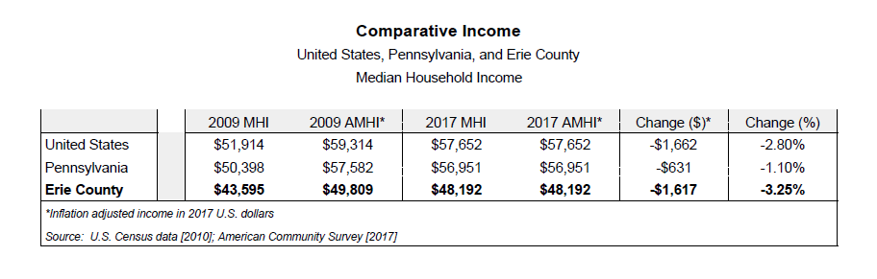
Income and Poverty
Erie County’s median household income and per capita income levels are below that of Pennsylvania continues to drop, with both income measurements having declined between 2009 and 2017. Erie’s median household income fell 3.25 percent in that same period from $49,809 to $48,192. In comparison, Pennsylvania experienced only a 1.1 percent reduction and median household income nationwide dropped 2.8 percent.25F
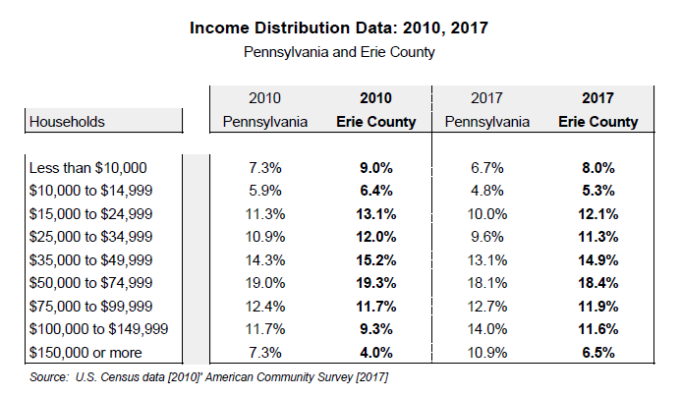
The divide between the upper-income households and lower-income households continues to grow across Erie County, while the percentage of households earning $50,000 to $74,999 (the middle-income households) has remained generally constant. The county saw a reduction of households earning less than $15,000 from 2010 to 2017 and, on the opposite end of the spectrum, the portion Erie County’s household population earning $75,000 and above grew significantly. Still, these percentages are below Pennsylvania’s household population, which earns $75,000 and over.
While the median family income in Erie County in 2017 was $62,251, the median family incomes in Pennsylvania and the United States were $72,692 and $70,850, respectively. This means that Erie County households earned less than their fellow Pennsylvanians and Americans. On an individual level, Erie County’s 2017 per capita income was $26,361, compared to $31,476 in Pennsylvania.26F

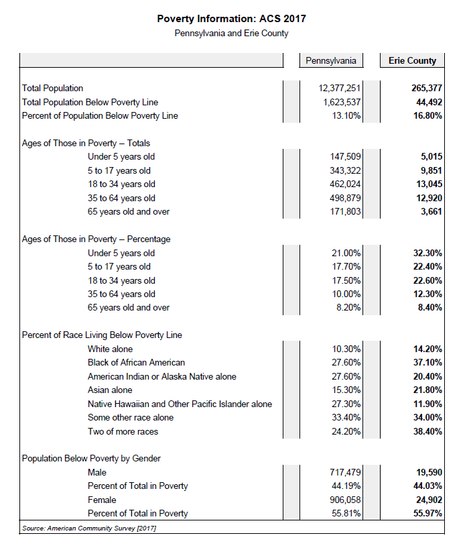
Erie County also experiences higher levels of poverty across all measurements when compared to Pennsylvania. In 2017, Erie County had 44,492 residents living below the poverty level – equating to roughly 17 percent of the population, according to the Erie Community Foundation’s Erie Vital Signs research.27F Pennsylvania’s individual poverty rate was 13.1 percent during this year.
Of those populations in poverty, female-headed families, children, and the elderly typically were most at-risk and experienced poverty at much higher rates than the population as a whole. In 2017, almost one of every three female-headed households in Erie County lived below the poverty line, as did more than 8 percent of the county’s elderly population. More significant is the County’s percentage of children living in poverty: almost 55 percent of all impoverished residents are under the age of 18 years old (with more than 32 percent being under the age of 5 years old).28F
Additionally, a correlation between race and poverty exists in Erie County: ethnic minorities make up a far larger percentage of those in poverty than in the entire population. For example, while African-Americans and Asians make up about 9 percent of the county’s total population, of those in poverty, these two races account for almost 59 percent. Though Pennsylvania exhibits similar numbers, they are not quite as large as those seen in Erie County. Similarly, and corresponding with single female-headed households being more at-risk, females make up the majority of those in poverty in Erie County, with 56 percent female to 44 percent male.²⁶ In essence, Erie County’s impoverished population is disproportionately minorities, generally children, and typically more female than male.

Statistical Breakdown
Zip Code | Population | Median HH Income | % GED or Higher | Square Mileage
16501 | 2044 | 10631 | 0.664 | 0.68
16503 | 16850 | 22918 | 0.727 | 2.45
16507 | 11088 | 28347 | 0.846 | 2.10
16502 | 16664 | 30458 | 0.877 | 2.55
16504 | 17322 | 40773 | 0.92 | 2.79
16508 | 16050 | 44643 | 0.93 | 24.59
16509 | 26810 | 44643 | 0.956 | 38.13
16443 | 1425 | 45074 | 0.871 | 11.28
16407 | 11317 | 45708 | 0.894 | 107.47
16411 | 1477 | 46696 | 0.89 | 17.77
16423 | 4450 | 47568 | 0.894 | 9.46
16438 | 8083 | 48521 | 0.885 | 103.26
16511 | 11382 | 48611 | 0.936 | 7.49
16401 | 6581 | 49796 | 0.842 | 57.02
16412 | 10480 | 49972 | 0.944 | 80.10
16417 | 8329 | 50169 | 0.926 | 46.41
16510 | 25625 | 52201 | 0.914 | 32.77
16428 | 12478 | 53162 | 0.922 | 73.40
16505 | 17168 | 53213 | 0.922 | 11.87
16426 | 3730 | 53750 | 0.952 | 27.08
16427 | 193 | 55000 | 0.94 | 0.26
16506 | 23720 | 59427 | 0.957 | 14.00
16441 | 10136 | 60435 | 0.931 | 112.65
16421 | 2518 | 60833 | 0.954 | 10.60
16410 | 1854 | 62917 | 0.938 | 22.53
16442 | 2958 | 63182 | 0.873 | 50.31
Erie County is large and economically diverse. There are 26 ZIP codes in Erie County, excluding college campuses. Erie County ZIP codes range in population from 193 in Mill Village (16427) – which consists entirely of its own ZIP code, unlike Elgin, Erie County’s least populated borough, that spans multiple ZIP codes – to 26,810 in part of Millcreek Township (16509). The average population per ZIP code area is 10,413. Within these areas, the average median household income is $47,256, and more than 89 percent of the population holds a GED or higher. Because Erie’s population lacks density, it is noteworthy, especially with regard to issues of access and availability, that the average square mileage of a ZIP code tabulation area is 33.41 sq. miles. The distribution of population in Erie County means that centers of commerce are commonly located in more densely populated or more highly trafficked areas. As one moves farther from urban and suburban centers, the access to goods and services becomes a challenge and mobility becomes a critical necessity in everyday life.

ZIP Code by Median Household Income
 | Total Stores | Chain | Non Chain
Poor Urban | 20 | 9 | 11
Poor Suburban | 16 | 15 | 1
Mid Income | 2 | 2 | 0
High Income | 4 | 3 | 1
Total | 42 | 29 | 13
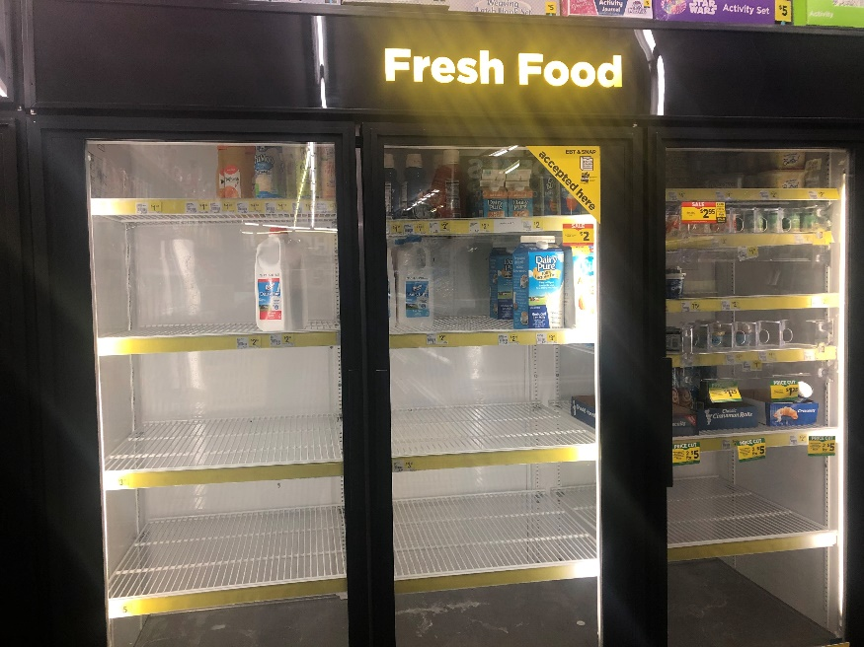
This project evaluates 12 of Erie’s ZIP code areas. The three poorest ZIP codes (16501, 16503, 16507) were located in Erie’s urban core. In order to evaluate urban and non-urban poverty, the three ZIP codes outside of the city with the lowest median household incomes (16509, 16443, 16407) were also selected to represent suburban and rural poverty. Those were contrasted with the three median ZIP codes (16411, 16423, 16438) and the three highest median income ZIP codes (16421, 16410, 16442). Because median household incomes vary greatly within small geographic areas and the spending power of an individual household can be equally unpredictable, food costs can be considered a constant in a household budget because regardless of the spending power of a household, the accessibility and availability of food within a target market can be a defining factor in the well-being of individuals and families. All of the interview subjects that researchers spoke with for this project indicated that cooking at home was their primary source for meals and that shopping at supermarkets was their preferred method of acquiring food. Moreover, multiple interview subjects identified groceries as “tremendously” impacting the household budget.
Photo credit: Jessica Hunter

The comparison among different types of grocery stores in select geographic areas was based on a survey of 42 stores in 12 geographic areas. A common assumption of consumer groups posits that lower-income households are further economically disadvantaged by higher
prices because of a lack of access to food stores and products.29F Survey results show that accessibility to sources of food, generally, is abundant in low-income ZIP code areas in both urban and suburban settings. Within these areas there is little variance in the average cost of food items. However, there is significant difference between the cost and availability of individual food items from store to store.
Average $ Basket of Goods/Category Unit
 | Produce | Meat/Dairy | Dry Goods | Can Goods | Bread/Grains | Personal Items
Non Chain | 1.34 | 4.41 | 2.55 | 1.35 | 2.05 | 2.26
Chain | 1.27 | 4.11 | 2.66 | 1.43 | 2.4 | 3.58
Poor Urban | 1.38 | 4.46 | 2.5 | 1.43 | 2.45 | 2.46
Poor Suburban | 1.21 | 4.01 | 2.73 | 1.45 | 2.3 | 4.08
Mid Income | 1.92 | 4.39 | 2.44 | 1.51 | 1.99 | 3.39
High Income | 1.06 | 3.59 | 2.08 | 1.05 | 2.21 | 3.01
Variance | 0.086 | 0.111 | 0.052 | 0.027 | 0.034 | 0.478
Thirty-six stores were located in low-income ZIP codes in Erie County. Chain stores (24) accounted for the majority of food stores in these areas and non-chain stores (12) accounted for the remainder, with the majority found in the urban core were non-chain. Chain stores in these areas include corporate grocery stores, such as Giant Eagle, Wegmans, Save A Lot, and Shur-Fine, but the classification also includes a number of pharmacies and variety stores, such as Rite Aid, CVS, Dollar General, and Family Dollar, which also carry food items. Also included in the survey were convenience stores, such as Country Fair, Sheetz, and Pilot. Pharmacies, variety stores, and convenience stores account for the majority of chain stores in low-income neighborhoods.
Food items surveyed were based on the USDA Thrifty Food Plan. Not all selected items were available at each grocery. It became clear that the question of food and its cost concerned availability more than accessibility. For example, in poor urban areas the availability of produce is scant by comparison to the number of stores with food available. Only six out of 20 stores offered apples, which appeared to have a significant impact on unit price that ranged from 99 cents per apple to $1.99 per pound (4-5 apples). In high-income areas, 75 percent of the stores carried apples with unit prices that ranged from 49 cents per apple to $1.77 per pound.
Item Availability  Per Area |  | Stores with produce availability
 | Total Stores | Apples | Bananas | Tomatoes | Lettuce | Green  Peppers | Carrots | Onions
Poor Urban | 20 | 6 | 6 | 8 | 9 | 6 | 7 | 10
Poor Suburban | 16 | 9 | 9 | 7 | 7 | 7 | 7 | 7
Middle Income | 2 | 1 | 1 | 1 | 1 | 1 | 1 | 1
High Income | 4 | 3 | 3 | 2 | 2 | 2 | 2 | 3

The survey illustrates that there is great disparity between the cost of basic nutritional staples, such as milk, white bread, cheese, and ground beef. The maximum price for a gallon of whole milk ranges from more than $6 per gallon in the low-income urban areas to less than $4 per gallon in high-income areas. A loaf of bread costs between 99 cents and $3.29 in poor urban areas, but the disparity in pricing is greater in high-income areas where costs range from 88 cents per loaf to $3.29. This price trend continues for other basic goods, such as cheese, but prices for ground beef – a low-cost protein – are leveled across income, presumably because of its limited shelf life compared to pasteurized and processed goods.
Milk: $/gallon  Avg.$ Max $ Min $  Poor Urban 4.03 6.36 3.29  Poor Suburban 3.85 4.99 3.3  Middle Income 4.22 4.44 4  High Income 3.53 3.67 3.31  Cheese: $/lb  Avg. $ Max $ Min $  Poor Urban 4.98 9.38 3.32  Poor Suburban 3.53 5.05 1.69  Middle Income 3.06 3.47 2.65  High Income 3.55 5.98 2.58 | White Bread: $/Loaf  Avg. $ Max $ Min $  Poor Urban 2.2 3.29 0.99  Poor Suburban 2.38 3 1.46  Middle Income 1.25 1.49 1  High Income 2.16 3.29 0.88  Ground Beef: $/lb  Avg. $ Max $ Min $  Poor Urban 3.52 4.5 2.49  Poor Suburban 3.89 5.99 2.89  Middle Income 5.99 5.99 5.99  High Income 3.56 3.99 2.98

Several researchers noted that in addition to fluctuations in pricing within geographic areas or income brackets, some stores, both chain and non-chain, failed to adequately identify the market price for items found throughout the store. This practice of price under-representation – not using price stickers on goods, shelves, or stands – was common in poor urban areas and appeared to correlate with higher unit prices and stores that accept food stamps. Customers for whom food makes up a significant portion of their household budget are, in these cases, making uninformed decisions related to their household food products. As one participant asked, “How can they stretch their budget when they don’t know what they are spending?”

The Community Poverty Index

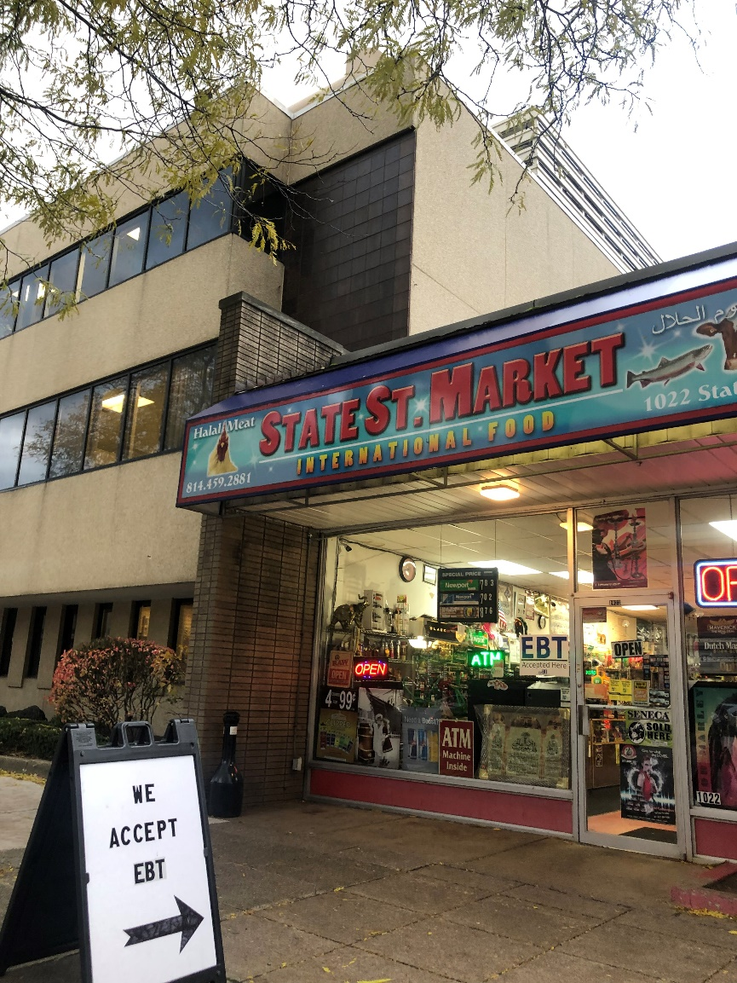
Median household income data, fair market rental prices, as well as food prices and availability were combined to create a community poverty index that reveals the variability – what we’ll refer to as the “weight” of poverty – in the cost of living from one ZIP code to another. Fair market rental costs for a three-bedroom apartment ($967) and food costs, controlled for availability, were divided by median household income to create a comparative value for each ZIP code included in this study. The index ranges from a low score of 1.59 in 16412 (Harborcreek Township) to a high score of 9.35 in 16501, located in the northern State Street corridor in the City of Erie. This means that it is roughly six times more expensive to live in 16501 than it is to live in Harborcreek Township. Only Harborcreek Township and ZIP code 16509 have supermarkets where all 49 products were available. Food availability accounts for approximately 0.25 of the index value. Therefore, one could assume that greater availability of market goods in low-income neighborhoods, such as 16501, would lower the index value from 9.35 to 9.10.
Photo Credit: Jessica Hunter

Zip Code | Population | Median HH Income | % GED or Higher | Avg. $/ Basket | Max Avail | Min Avail | CPI
16501 | 2044 | 10631 | 0.664 | 71.05 | 36 | 15 | 9.35
16503 | 16850 | 22918 | 0.727 | 60.55 | 48 | 9 | 4.23
16507 | 11088 | 28347 | 0.846 | 101.98 | 41 | 29 | 3.56
16509 | 26810 | 44643 | 0.956 | 79.7 | 49 | 11 | 2.17
16443 | 1425 | 45074 | 0.871 | 89.89 | 48 | 24 | 2.15
16407 | 11317 | 45708 | 0.894 | 91.96 | 36 | 36 | 2.32
16411 | 1477 | 46696 | 0.89 | 132.9 | 0 | 0 | 2.35
16423 | 4450 | 47568 | 0.894 | 132.9 | 0 | 0 | 2.31
16438 | 8083 | 48521 | 0.885 | 132.9 | 43 | 33 | 2.10
16421 | 2518 | 60833 | 0.954 | 96.49 | 49 | 42 | 1.59
16410 | 1854 | 62917 | 0.938 | 88.17 | 0 | 0 | 1.67
16442 | 2958 | 63182 | 0.873 | 79.84 | 36 | 32 | 1.63
There is also a high correlation between index value and education. For example, higher educational attainment appears to offset moderately lower household incomes, such as those in ZIP codes 16509 and 16421. Because educational attainment was not an independent variable in this particular study, this observation deserves additional research. However, it reflects the findings of previous research that links educational attainment with poverty reduction strategies.

Conclusion

Food availability has the power to lower the poverty rates based on the poverty index score of a geographic area by .25. It is prudent to conclude, therefore, that increasing the availability of food products in areas with high accessibility to food stores should have a positive impact on poverty levels in those areas. Increasing availability, however, remains a challenge. Stores, such as Dollar General and Family Dollar, which offer few nutritional food options and are not likely to adjust their business model to increase grocery offerings, continue to open new locations in rural and low-income urban areas. In fact, three new Dollar Generals open each day across the United States and the chain has more locations than McDonald’s.30F The presence of such stores in Erie County is not likely to decline in the near future and that comes with a price.
Access to fresh food needs to be a public policy decision as much as it needs to be a demand of consumers. Subsidies are regularly disbursed to companies pledging to fill a community void and creating jobs. These subsidies also need to be quality driven to ensure that underserved communities are not only served by the least best option available to them. In sections of New York City policy makers have added tax breaks and granted zoning variances to encourage the establishment and expansion of fresh food markets in neighborhoods that have high rates of poverty and diet-related diseases. As a result, the city has subsidized 21 supermarkets, which have created an additional 940 full-time jobs in targeted areas of the Bronx, Brooklyn, Harlem, and Queens.31F
As the region engages in concerted community development initiatives that align with the City of Erie comprehensive plan, Erie Refocused, and the county’s guiding document, Emerge 2040, those charged with its stewardship must be as purposeful about placemaking as they are about economic development. That includes creating and enforcing ordinances and financial incentives that encourage the dissemination of quality foods that serve as the foundation of a healthier and more prosperous community.

Recommendations

- Create fresh food coop arrangements to increase the availability of fresh foods to grocers in low-income areas and offer business assistance and consulting to those grocers who would like to proliferate fresh foods but lack the knowledge or resources to do so.

- Create fresh food specific Local Economic Revitalization Tax Assistance incentives in select areas tied to both the quality of goods sold and the quality of jobs created.

- Monitor Blue Zone benchmarks in Corry with the potential for expansion countywide.

- Support the sale of local foods across the community by offering incentives and encouraging the establishment of farmers’ markets.

- Review and revise zoning regulations to promote policies that support community gardens and the distribution of yield.

- Ensure that residents can access healthy and affordable food through public transportation—by realigning bus routes, providing free shuttles, or other means.

- Efforts should be made to replicate this study on a decennial basis in an effort to measure costs of living across Erie County as well as the impact of food availability on households across income.

Works Cited
Buki, C., et al. (2016, March 1). Erie Refocused: City of Erie, PA: Comprehensive Plan and Community Decision-Making Guide. Erie Planning Commission: http://www.erie.pa.us/Portals/0/Content/ECD/Erie%20Refocused%202016.pdf
Chung, C. & Meyers, S. (1999). Do the poor pay more for food? An analysis of grocery store availability and food price disparities. Journal of Consumer Affairs 33(2), pp. 276-296.
Circles USA. (n.d.) Mitigating and Cliff Effects. Circles USA: https://www.circlesusa.org/the-circles-solution/systemic-barriers/
Erie Vital Signs. (n.d). Economy: People Living in Poverty. Erie Community Foundation: http://erievitalsigns.org/economy/people-living-in-poverty
Goldstein, J. (2012, August 1). How the poor, the middle class, and the rich spend their money. NPR:Planet Money: https://www.npr.org/sections/money/2012/08/01/157664524/how-the-poor-the-middle-class-and-the-rich-spend-their-money
Graney, Grossman, Colosimo and Associates, Inc. (2003, January 1). Erie County Demographic Study. Erie County Department of Planning: https://www.eriecountypa.gov/media/19672/erieco_demo_study_jan_03.pdf

Martin, E. (2018, Jan. 18). Only 39 percent of Americans have enough savings to cover a $1,000 emergency. CNBC: Make It: https://www.cnbc.com/2018/01/18/few-americans-have-enough-savings-to-cover-a-1000-emergency.html
McGreal, C. (2018, Aug. 13). Where even Walmart won't go: How Dollar General took over rural America. The Guardian: https://www.theguardian.com/business/2018/aug/13/dollar-general-walmart-buhler-haven-kansas

National Education Association. (n.d.). Facts about Child Nutrition. National Education Association: http://www.nea.org/home/39282.htm
National Public Radio. (2001). NPR-Kaiser Family Foundation-Kennedy School of Government Poverty Study. NPR:Online: https://www.npr.org/programs/specials/poll/poverty/poll.html
Pennsylvania Department of Health. (n.d.). Pennsylvania County Health Profiles: Erie Pennsylvania Department of Health: https://www.health.pa.gov/topics/HealthStatistics/VitalStatistics/CountyHealthProfiles/Documents/current/erie.aspx

Pennsylvania Department of Labor and Industry. (n.d.) Labor Force, Employment, and Unemployment for Pennsylvania: 2000-2017. Geographic Solutions, Inc: https://paworkstats.geosolinc.com/vosnet/dashboards/defaultana.aspx?menuid=MENU_START_PAGE_DASHBOARD_ANA

Rink, M. (2018, March 11). Numbers stagnate, despite efforts to reduce child poverty in Erie. GoErie: http://www.goerie.com/news/20180311/numbers-stagnate-despite-efforts-to-reduce-child-poverty-in-erie

United States Census Bureau. 1950-2010 United States Census: United States. United States Census Bureau. Accessed from Fact Finder: Community Facts page: https://factfinder.census.gov/faces/nav/jsf/pages/community_facts.xhtml

Ungar-Sargon, B. (2018, April 5). Have city subsidies to supermarkets made NYC healthier. CityLab. https://citylimits.org/2016/04/05/have-city-subsidies-to-supermarkets-made-nyc-healthier/

Wertz, J. (2018, March 28). The State of Erie Industry in 2018. Erie Reader: https://www.eriereader.com/article/the-state-of-erie-industry-in-2018

Williams, M. & Ferenchik, M. (2019, January 1). Despite strengthening economy, midsized Ohio cities have been left behind. Marion Star: https://www.marionstar.com/story/news/local/2019/01/01/despite-growing-economy-midsize-ohio-cities-have-been-left-behind/2380667002/

World Population Review. (2018). Population of Counties in Pennsylvania (2018). World Population Review: http://worldpopulationreview.com/us-counties/pa/

Works Consulted
24/7 Wall Street. (2017, November 3). The Worst Cities for Black Americans. USA Today: https://www.usatoday.com/picture-gallery/money/2017/11/03/the-worst-cities-for-black-americans/107304738/

Akee, R. (2018, July 5). How Do We Get More Young People to Vote as Adults? Cash Transfers to Their Parents Could Help. Brookings Institute: https://www.brookings.edu/blog/up-front/2018/07/05/how-do-we-get-more-young-people-to-vote-as-adults-cash-transfers-to-their-parents-could help/?utm_campaign=Brookings%20Brief&utm_source=hs_email&utm_medium=email&utm_content=64283421

Algert, S. J., et al. (2006). Disparities in Access to Fresh Produce in Low-Income Neighborhoods in Los Angeles. American Journal of Preventive Medicine 30(5), pp. 365-370.

Amis, P. (1995, April 1). Making Sense of Urban Poverty. Environment and Urbanization 7(1), pp. 145-158.

Associated Press. (2018, October 24). MacArthur Foundation Announces Millions in Justice Grants. US News: https://www.usnews.com/news/cities/articles/2018-10-24/macarthur-foundation-announces-millions-in-justice-grants

Badger, E. & Bui, Q. (2018, October 1). Detailed Maps Show How Neighborhoods Shape Children for Life. New York Times: https://www.nytimes.com/2018/10/01/upshot/maps-neighborhoods-shape-child-poverty.html

Bebbington, A. (1999). Capitals and Capabilities: A Framework for Analyzing Peasant Viability, Rural Livelihoods and Poverty. World Development 27(12), pp. 2021-2044.

Blank, R. M. (2008, March 13). Presidential Address: How to Improve Poverty Measurement in the United States. Journal of Policy Analysis and Management 27(12), pp. 233-254.

Brown, D. L. (2009, May 18). The High Cost of Poverty: Why the Poor Pay More. Washington Post: http://www.washingtonpost.com/wp-dyn/content/article/2009/05/17/AR2009051702053.html?noredirect=on

Chang, A. (2018, September 12). The Subtle Ways Colleges Discriminate Against Poor Students, Explained With a Cartoon. Vox: https://www.vox.com/2017/9/11/16270316/college-mobility-culture

Chingos, M. (2018, August 16). A Promising Alternative to Subsidized Lunch Receipt as a Measure of Student Poverty. Brookings Institute: https://www.brookings.edu/research/a-promising-alternative-to-subsidized-lunch-receipt-as-a-measure-of-student-poverty/?utm_campaign=Brookings%20Brief&utm_source=hs_email&utm_medium=email&utm_content=65260970

Circles USA. (2016, August 1). Addressing the Cliff Effect. Circles USA: https://www.circlesusa.org/wp-content/uploads/2016/08/Addressing-the-Cliff-Effect.pdf

Cohen, R. (2017, September 26). Education Isn’t the Key to a Good Income. The Atlantic: https://www.theatlantic.com/education/archive/2017/09/education-and-economic-mobility/541041/

De Vita, C. J. (2006, November 1). A Profile of Nonprofit Organizations in Erie County, Pennsylvania. The Urban Institute: http://webarchive.urban.org/UploadedPDF/411395_Nonprofit_Organizations_Erie.pdf

DePillis, L. (2017, November 28). The Case for Charging Rich and Poor Shoppers Different Prices. CNN:Business: https://money.cnn.com/2017/11/28/news/economy/grocery-store-prices-wealth/index.html

Desmond, M. (2016). Evicted. New York, New York: Crown.

Desmond, M. (2018, September 11). Americans Want to Believe Jobs Are the Solution to Poverty. They’re Not. New York Times: https://www.nytimes.com/2018/09/11/magazine/americans-jobs-poverty-homeless.html

Eastwood, R. & Lipton, M. (2004). Rural and Urban Income Inequality and Poverty: Does Convergence between Sectors Offset Divergence Within Them? In: Cornia, GA (ed.) Inequality, Growth and Poverty In an Era of Liberalization and Globalization. Oxford University Press, pp. 112-141. ISBN 0199271410

Economic Innovation Group. (2018, October 1). From Great Recession to Great Reshuffling: Charting a Decade of Change across American Communities. Economic Innovation Group: https://eig.org/dci

Erie Times-News. (2018, January 29). Study: 16501 is State’s Poorest Zip Code. GoErie: http://www.goerie.com/news/20180129/study-eries-16501-is-states-poorest-zip-code

Favreau, J. (Host). (2018, August 13). The 1% [Audio podcast]. Retrieved from https://crooked.com/podcast/chapter-8-the-1/

Friedman, T. (2018, July 3). Where American Politics Can Still Work: From the Bottom Up. New York Times: https://www.nytimes.com/2018/07/03/opinion/community-revitalization-lancaster.html

Gooding, P. (2016). Consumer Price Inflation: The 2016 Basket of Goods and Services. Office for National Statistics: https://www.ons.gov.uk/economy/inflationandpriceindices/articles/consumerpriceinflationbasketofgoodsandservices/2016

Grady, C. (2018, July 24). Why Public Libraries are Still Essential in 2018. Vox: https://www.vox.com/culture/2018/7/24/17603692/public-libraries-essential-forbes-amazon

Greater Erie Community Action Committee. (2016). Community Needs Assessment 2016. GECAC: Report.

Griffith, D. & Kissam, E. (1995). Working Poor: Farmworkers in the United States. Philadelphia, Pennsylvania: Temple University Press.

Harrington, M. (1997). The Other America: Poverty in the United States. New York, New York: Simon & Schuster.

Haughton, J. & Khandker, S. R. (2009, March 27). Handbook on Poverty and Inequality. Washington D.C.: World Bank. http://documents.worldbank.org/curated/en/488081468157174849/Handbook-on-poverty-and-inequality

Hickman, B. (2015, March 13). Lack of Education is Root Cause of Poverty. Rochester Business Journal: https://rbj.net/2015/03/13/lack-of-education-is-root-cause-of-poverty/

Holzer, H. J., et al. (2007, January 24). The Economic Costs of Poverty in the United States: Subsequent Effects of Children Growing Up Poor. Center for American Progress: https://www.americanprogress.org/issues/poverty/reports/2007/01/24/2450/the-economic-costs-of-poverty/

Institute for Research on Poverty. (n.d.). How is Poverty Measured?. University of Wisconsin-Madison: https://www.irp.wisc.edu/resources/how-is-poverty-measured/

JizzleArt. (2012, April 2). Introduction to the Working Poor. YouTube: https://www.youtube.com/watch?v=y9AIjxqUzqE&feature=youtu.be

Johnson, D. S., et al. (2001, May 1). A Century of Family Budgets in the United States. Monthly Labor Review: May 2001, pp. 28-45.

Khazan, O. (2017, December 28). Food Swamps are the New Food Deserts. The Atlantic: https://www.theatlantic.com/health/archive/2017/12/food-swamps/549275/

Kneebone, E. (2018, September 19). Which Places Made Progress Against Poverty in 2019?. The Brookings Institution: https://www.brookings.edu/blog/the-avenue/2018/09/19/which-places-made-progress-against-poverty-in-2017/?utm_campaign=Metropolitan%20Policy%20Program&utm_source=hs_email&utm_medium=email&utm_content=66266040

Lawler, D. (2018, August 6). The Two Biggest Trends on Earth: Share of Population Living on Less than $5.50 a Day. Axios: https://www.axios.com/population-living-in-poverty-around-the-world-4e9a1682-8635-46f5-8c20-43264b765c5e.html

Leefeldt, E. (2018, August 21). America’s Rich are Moving to the Coasts as the Poor Go Inland. CBS News:Money Watch: https://www.cbsnews.com/news/american-migration-rich-move-to-coasts-poor-to-the-heartland/

Lewis, L. & Cuzzola-Kern, A. (2007, April 1). The High Cost of Poverty: It Affects Us All. The Erie Community Foundation: Report.

McGreal, C. (2018, August 13). Where Even Walmart Won’t Go: How Dollar General Took Over Rural America. The Guardian: https://www.theguardian.com/business/2018/aug/13/dollar-general-walmart-buhler-haven-kansas?utm_content=buffera802f&utm_medium=social&utm_source=facebook.com&utm_campaign=buffer

Muro, M., et al. (2015, February 1). America’s Advanced Industries: What They Are, Where They Are, and Why They Matter. The Brookings Institution: https://www.brookings.edu/research/americas-advanced-industries-what-they-are-where-they-are-and-why-they-matter/

Myers, C. K., et al. (2011, July 28). Retail Redlining: Are Gasoline Prices Higher in Poor and Minority Neighborhoods?. Economic Inquiry 49(3), pp. 795-809.

Myers, K. (2018, May 3). The Top Nine Causes of Global Poverty. Concern Worldwide U.S.: https://www.concernusa.org/story/top-9-causes-global-poverty/

Neumark, D., et al. (2018, June 1). Helping Without Hurting: The Long-Run Effects of Anti-Poverty Policies on Disadvantaged Neighborhoods. Employment Policies Institute, pp. 4-44.

Nevins, S. & Hoffman, J. (Producers). (2012). The Weight of the Nation: Part 3. HBO: https://www.youtube.com/watch?v=BmcZRgWBdwQ&feature=youtu.be

Nohara, Y. (2018, June 24). In One of the World’s Richest Countries, Most Single Mothers Live in Poverty. Bloomberg: https://www.bloomberg.com/news/features/2018-06-24/the-children-of-japan-s-single-mothers-are-living-in-poverty

Ordway, D. M. & Bryant, H. (2018, September 4). Covering Poverty: What to Avoid and How to Get it Right. Journalist’s Resource: https://journalistsresource.org/tip-sheets/covering-poverty-avoid-get-right?utm_source=JR-email&utm_medium=email&utm_campaign=JR-email%22%20target=%22_self%22

Raja, K. (2013, November 8). Poverty and Racism Inextricably Linked, Says UN Expert. Third World Network: http://www.socialwatch.org/node/16324

Reichel, C. (2018, July 3). Nearly 2 Million U.S. Families Face Financial Hardship for Ongoing Heart Care. Journalist’s Resource: https://journalistsresource.org/studies/government/health-care/heart-disease-health-costs

Reichel, C. (2018, May 14). Covering Rural America: What Reporters Get Wrong and How to Get it Right. Journalist’s Resource: https://journalistsresource.org/tip-sheets/reporting/rural-america-reporting-tipsheet-sarah-smarsh

Resnikoff, N. (2014, March 13). Race is the Elephant in the Room When It Comes to Inequality. MSNBC: http://www.msnbc.com/msnbc/washingtons-silence-the-racial-wealth-gap#50880

Rink, M. (2018, July 31). United Way on Mission to ‘Crush Poverty.’ GoErie: http://www.goerie.com/news/20180731/united-way-on-mission-to-crush-poverty

Rogers, C. D. (2014, July 1). Poverty Analysis Using Alternative Poverty Measures and Geospatial Technology in the Buffalo-Niagara Falls, New York Metropolitan Statistical Area: 1970-2000. URISA Journal 26(2), pp. 51+.

Rothwell, J. (2015, May 6). Sociology’s Revenge: Moving to Opportunity (MTO) Revisited. The Brookings Institution: https://www.brookings.edu/blog/social-mobility-memos/2015/05/06/sociologys-revenge-moving-to-opportunity-mto-revisited/

Severson, K. (2018, July 31). The Freshest Ideas Are in Small Grocery Stores. New York Times: https://www.nytimes.com/2018/07/31/dining/grocery-store.html

Thompson, D. (2015, April 7). Rich People Are Great at Spending Money to Make their Kids Rich, Too. The Atlantic: https://www.theatlantic.com/business/archive/2015/04/being-rich-means-having-money-to-spend-on-being-richer/389871/

Trilling, D. (2018, January 18). How Minimum-Wage Increases Squeeze the Poor. Journalist’s Resource: https://journalistsresource.org/studies/economics/inequality/minimum-wage-grocery-prices-poorest-workers

Turner, A. (2015, June 11). The Business Case for Racial Equity in Michigan. Altarum Institute, W. K. Kellogg Foundation: https://www.wkkf.org/resource-directory/resource/2015/05/the-business-case-for-racial-equity-in-michigan-june-2015

United Way of Erie County. (2017, November 9). Poverty Rates in Erie and Erie County. Data Tables.

Warner, M. & Daniels M., (2018, July 19). Governors Can Determine the Future of Work. Santa Fe New Mexican: http://www.santafenewmexican.com/opinion/commentary/governors-can-determine-the-

future-of-work/article_0479bbbd-1617-59dc-b508-d21d28c5950f.html

Wratten, E. (1995, April 1). Conceptualizing Urban Poverty. Environment and Urbanization 7(1), pp. 11-38.

Erie Vital Signs. (n.d). Economy: People Living in Poverty. Erie Community Foundation: http://erievitalsigns.org/economy/people-living-in-poverty
Martin, E. (2018, Jan. 18). Only 39 percent of Americans have enough savings to cover a $1,000 emergency. CNBC: Make It: https://www.cnbc.com/2018/01/18/few-americans-have-enough-savings-to-cover-a-1000-emergency.html
Circles USA. (n.d.) Mitigating and Cliff Effects. Circles USA: https://www.circlesusa.org/the-circles-solution/systemic-barriers/
Wertz, J. (2018, March 28). The State of Erie Industry in 2018. Erie Reader: https://www.eriereader.com/article/the-state-of-erie-industry-in-2018
Williams, M. & Ferenchik, M. (2019, January 1). Despite strengthening economy, midsized Ohio cities have been left behind. Marion Star: https://www.marionstar.com/story/news/local/2019/01/01/despite-growing-economy-midsize-ohio-cities-have-been-left-behind/2380667002/
Rink, M. (2018, March 11). Numbers stagnate, despite efforts to reduce child poverty in Erie. GoErie: http://www.goerie.com/news/20180311/numbers-stagnate-despite-efforts-to-reduce-child-poverty-in-erie
National Education Association. (n.d.). Facts about Child Nutrition. National Education Association: http://www.nea.org/home/39282.htm
Goldstein, J. (2012, August 1). How the poor, the middle class, and the rich spend their money. NPR:Planet Money: https://www.npr.org/sections/money/2012/08/01/157664524/how-the-poor-the-middle-class-and-the-rich-spend-their-money
Chung, C. & Meyers, S. (1999). Do the poor pay more for food? An analysis of grocery store availability and food price disparities. Journal of Consumer Affairs 33(2), pp. 276-296.
Ibid., p. 276
U.S. Census Profile of General Population and Housing Characteristics data from 1950, 2010 and U.S. Census American Community Survey from 2017: Erie County, PA; Pennsylvania; United States.
U.S. Census Profile of General Population and Housing Characteristics data from 2010 and U.S. Census American Community Survey from 2017: Erie County, PA.
U.S. Census Profile of General Population and Housing Characteristics data from 2010 and U.S. Census American Community Survey from 2017: Conneaut Township, PA; Summit Township, PA; Wattsburg Borough, PA; Millcreek Township, PA; Harborcreek Township, PA; Greenfield Township, PA; McKean Borough, PA; Fairview Township, PA; Fairview Borough, PA.
U.S. Census Profile of General Population and Housing Characteristics data from 2010 and U.S. Census American Community Survey from 2017: Elgin Borough, PA; Platea Borough, PA; Amity Township, PA; Concord Township, PA; Erie City, PA; Corry City, PA.
World Population Review. (2018). Population of Counties in Pennsylvania (2018). World Population Review: http://worldpopulationreview.com/us-counties/pa/
U.S. Census Profile of General Population and Housing Characteristics data from 2000, 2010 and U.S. Census American Community Survey from 2017: Erie County, PA; Pennsylvania.
National Conference of State Legislatures. (2018). Teen Pregnancy Prevention. National Conference of State Legislatures: http://www.ncsl.org/research/health/teen-pregnancy-prevention.aspx#2.
U.S. Census Profile of General Population and Housing Characteristics data from 2000, 2010 and U.S. Census American Community Survey from 2017: Erie County, PA; Pennsylvania.
U.S. Census American Community Survey from 2017: Erie City, PA; Millcreek Township, PA; Edinboro Borough, PA; Conneaut Township, PA; Elgin Borough, PA.
U.S. Census Profile of General Population and Housing Characteristics data from 2000, 2010 and U.S. Census American Community Survey from 2017: Erie County, PA; Pennsylvania.
U.S. Census Profile of General Population and Housing Characteristics data from 2000, 2010: Erie City, PA; Corry City, PA; Millcreek Township, PA; Erie County, PA; Amity Township, PA; Venango Township, PA.
U.S. Census Profile of General Population and Housing Characteristics data from 2010 and U.S. Census American Community Survey from 2017: Erie County, PA.
U.S. Census Educational Attainment by Sex data from 2000 and U.S. Census American Community Survey from 2017: Erie County, PA; Pennsylvania.
Pennsylvania Department of Labor and Industry. (n.d.) Labor Force, Employment, and Unemployment for Erie County, PA and Pennsylvania: 2000-2017. Geographic Solutions, Inc: https://paworkstats.geosolinc.com/vosnet/dashboards/defaultana.aspx?menuid=MENU_START_PAGE_DASHBOARD_ANA
U.S. Census Profile of Selected Economic Characteristics data from 2010 and U.S. Census American Community Survey from 2017: Pennsylvania; Erie County, PA.
U.S. Census Profile of Selected Economic Characteristics data from 2010 and U.S. Census American Community Survey from 2017: Pennsylvania; Erie County, PA.
U.S. Census Profile of Selected Economic Characteristics data from 2010 and U.S. Census American Community Survey from 2017: United States; Pennsylvania; Erie County, PA.
U.S. Census Profile of Selected Economic Characteristics data from 2010 and U.S. Census American Community Survey from 2017: United States; Pennsylvania; Erie County, PA.
Erie Vital Signs. (n.d). Economy: People Living in Poverty. Erie Community Foundation: http://erievitalsigns.org/economy/people-living-in-poverty
U.S. Census Profile of Selected Economic Characteristics data from American Community Survey from 2017: Erie County, PA.
Chung, C. & Meyers, S. (1999). Do the poor pay more for food? An analysis of grocery store availability and food price disparities. Journal of Consumer Affairs 33(2), pp. 276-296.
McGreal, C. (2018, Aug. 13). Where even Walmart won't go: How Dollar General took over rural America. The Guardian. https://www.theguardian.com/business/2018/aug/13/dollar-general-walmart-buhler-haven-kansas
Ungar-Sargon, B. (2018, April 5). Have city subsidies to supermarkets made NYC healthier. CityLab. https://citylimits.org/2016/04/05/have-city-subsidies-to-supermarkets-made-nyc-healthier/

